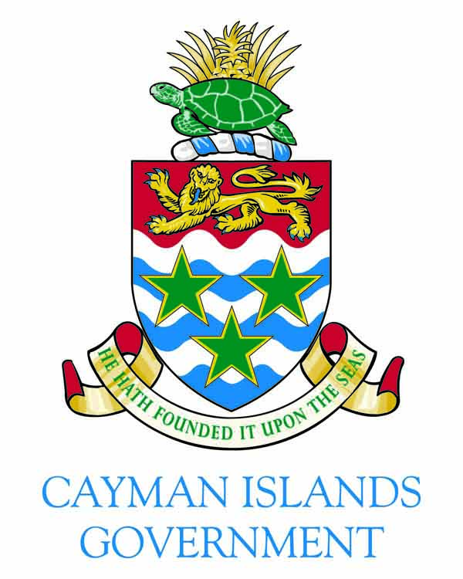

Welcome Remarks to Red Ensign Group Conference
By Acting Governor Hon. Franz Manderson
9 a.m., Tuesday, 11 July, 2017
Grand Cayman Marriott Beach Resort

(Protocol)
Good morning ladies and gentlemen,
It is with great pleasure that I welcome you to the Red Ensign Group Conference 2017.
For those of you who were here with us when we last hosted this conference in 2008, welcome back. To those who are new to our shores, I bring you warm Caymanian greetings and I trust it will be a start of a long association with these Isles
It is indeed an honour and pleasure to host the REG Conference this week.
Over the years, REG members have been collaborating, working together and accomplishing great things. I am looking forward to hearing the outcome of your deliberations from this milestone meeting.
I trust that you will find plenty on the packed and diverse agenda to engage you during the next few days and, for those of you who have come from overseas, I hope you will also find time to enjoy Cayman’s fine attractions and hospitality before you go home.
It is an honour to be part of the Red Ensign Group and the British fleet, which is synonymous with quality shipping because of its high technical, social and administrative standards. The REG Strategy ethos states this well: “Strength and quality through collaboration.”
The REG conference each year allows its members an opportunity for detailed face-to-face discussion of a wide variety of matters and shared interests. The conference allows the opportunity to share best practice and to discuss ways to optimise performance on the British register in the international arena, both in terms of commercial success and in setting exemplary standards in meeting international maritime obligations.
The conference is supported by an REG Technical Forum group, which provides a colloquium to assist with ensuring consistent application of technical policy across the British fleet by working closely with REG colleagues through exchange of knowledge and experiences. The forum is also responsible for the development of new technical standards for the maritime industry, including the Large Yacht Code and Passenger Yacht Code, both of which are now recognised as industry best practice standards.
I believe you have chosen the perfect venue for this conference. Ours is a history steeped in seafaring tradition.
Our forefathers were shipbuilders, seamen, fishermen and merchant marines. My own father and grandfather were included in those men who left our shores to ply the seas.
Our ties to the sea are inextricable and it is this passion that drives us to develop this industry in honour of those who went before us and for the generations to come.
We continue to maintain an enviable position in shipping; indeed at the crossroads to the Americas. We are conveniently located between North and South America, not too far from the Panama Canal and a convenient last stop for ships going south to Cape Horn.
Our shipping registry has implemented the necessary legislative and regulatory framework to qualify for the top-of-the class designation since 1903 when George Town was formally recognised as a British Port of Registry.
Fast forward to 1991 when the Cayman Islands Shipping Registry obtained British Category 1 Status, which meant we could register vessels of any size and type provided they met international standards. We continue that tradition today.
We hire and train qualified professionals in the areas of security and port control, surveying maritime law, registration and crew compliance to help us keep that top-of-the class designation. In March this year, for the sixth year running, the International Chamber of Shipping commended our Shipping Registry as top-of-class in its 2016-2017 Annual Flag State Performance Table.
With this distinction we are keeping company with such shipping powerhouse jurisdictions as Greece, France, Singapore, Norway, Japan and the United Kingdom.
Those of you in this room know that the International Chamber of Shipping has been the principal international trade association for the shipping industry since 1921. So being recognised by them is no mean feat and assures those who would do business with Cayman that the opportunities that exist here are not only numerous, but top-notch.
We are a world-class business centre and our Maritime Authority and Shipping Registry are one of the many ways in which we are able to diversify Cayman’s economy.
We are also attractive because our legislation enables the registration of passenger vessels in a private capacity. It is a benefit that isn’t available from many other flags.
Cayman is indeed at the forefront of the maritime and financial services industries, we have a tourism product that is second-to-none and we have a willing and trained workforce ready to compete on any stage. And to top it off, Cayman is an excellent place to live, work and play.
I am delighted you are here and I hope that you are able to take some time to enjoy all that Cayman has to offer, from our world-class cuisine to our beautiful people. If you do, I believe you will leave with a longing to return. Again, welcome.
Thank you.

###

